**MAT 5003/ AIM 5003 Numerical Methods**

**Project 1. Forward and inverse kinematics (robot finding)**

The two-link robotic manipulator is a classic example studied in introductory robotics courses. The physical system is shown in Fig. 1.

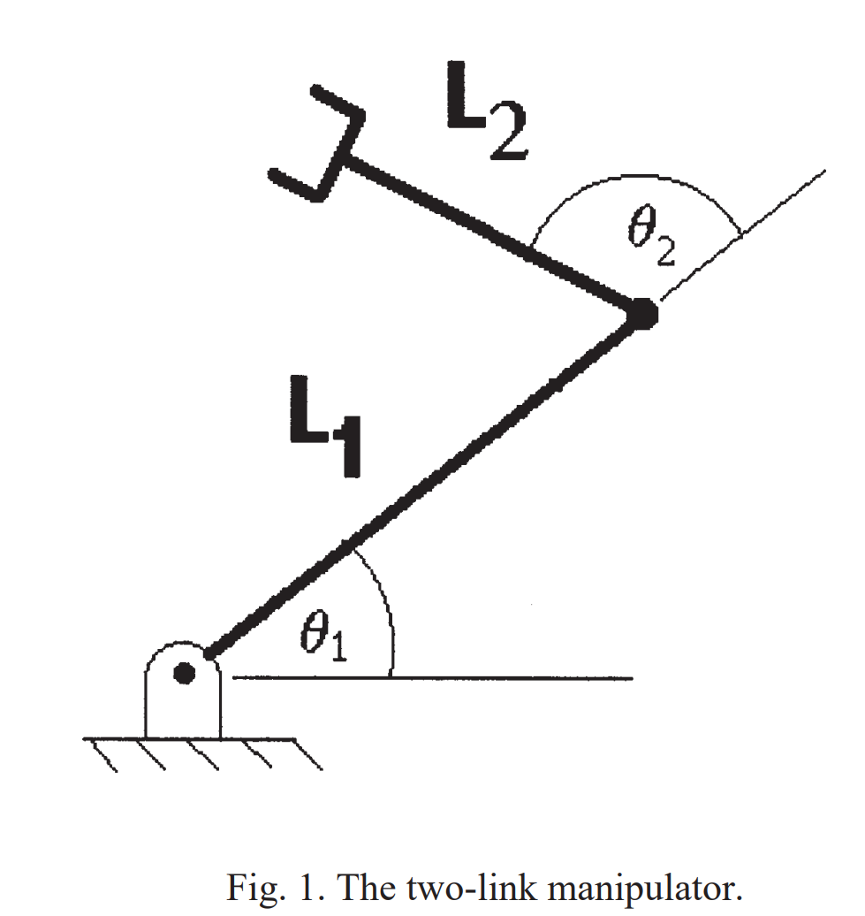

The equations describing the x–y location of the robot’s hand with respect to the base of the robot are known as the ‘forward kinematic equations’ of the manipulator. They are as follows:



The lengths L1 and L2 are fixed.

An equally important computation involves the ability to determine the appropriate angles θ1 and θ2 to yield a desired x–y position of the robot hand. This is known as the ‘inverse kinematics’ problem of a robotic manipulator.

1. Develop a numerical function to compute the forward kinematics of a manipulator (from equations (1) and (2)) given the angles θ1 and θ2.
2. Describes the set of x–y points which are which are within the reach of the manipulator.
3. Develop a numerical function to compute the inverse kinematic solution of the manipulator (i.e. determine θ1 and θ2 in equations (1) and (2)) given the hand location x and y.)

You will need to do algebraic and trigonometric manipulations to reduce (1) and (2) to two equations that can be solved with the methods from the course

1. To solve the equations, apply (a) the bisection method (b) the fixed point iteration method (c) the Newton method. There are some x–y points which are outside the reach of the manipulator; this must be checked before solution begins. Except for special cases, every x–y point within the reach of the manipulator can be achieved by two different sets of angles (the classic ‘elbow up’ and ‘elbow down’ solutions for a manipulator).
2. Pick several values for L1, L2, x, y to test the functions.

**Project components:**

1. **Technical Report.** A typed-up report of at least 3-5 pages that carefully summarizes the theory and presents a few worked-out examples. All resources used need to be cited.   
   A report must abide by the following format:
   1. Abstract
   2. Introduction
   3. Body of the Project and the Sections
   4. Computer Experiments/Simulations and Results
   5. Conclusions
   6. References cited.

The report should be emailed to the instructor as a PDF by the deadline.

1. **Computer Code.** Write computer code that performs the tasks specified by the project.

The computer code should be included as an appendix of the report.

1. **Power Point Presentation.** Prepare a 5 min presentation that will summarize the topic, without going into all details.